Errands Board Notes

Initial Notes

Board Information
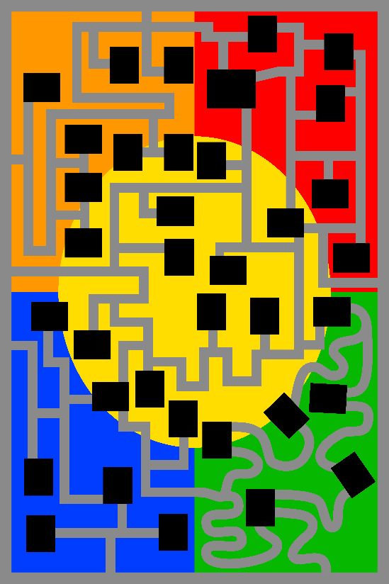

Board Sections

Neighborhood Section
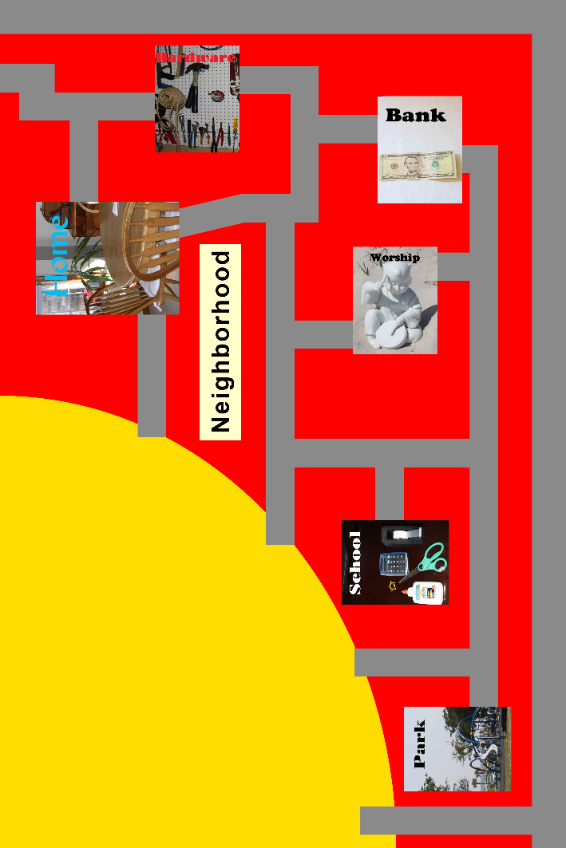
- Little houses (Seen from above or isometric?)
- Pond/Park?
- Asphalt roads?

Mall Section
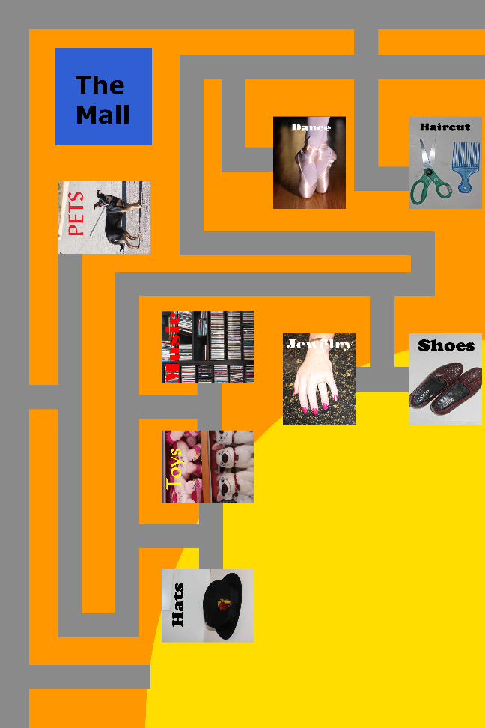
- Paths like mall flooring
- Little vendor kiosks?
- Potted plants
- “Sale sale sale!” signage
- Parking lot(s)?

Downtown Section
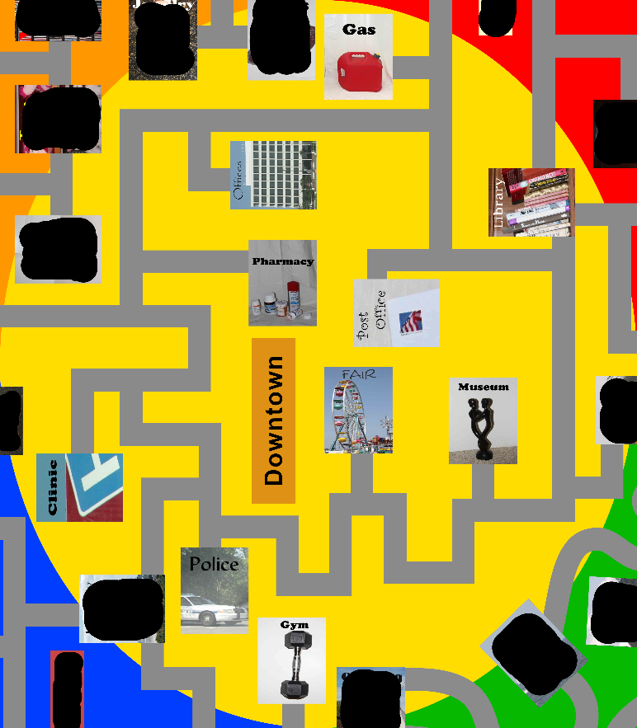
- Downtown…stuff?
- Office buildings
- Buses
- Fountain?

Industry Section
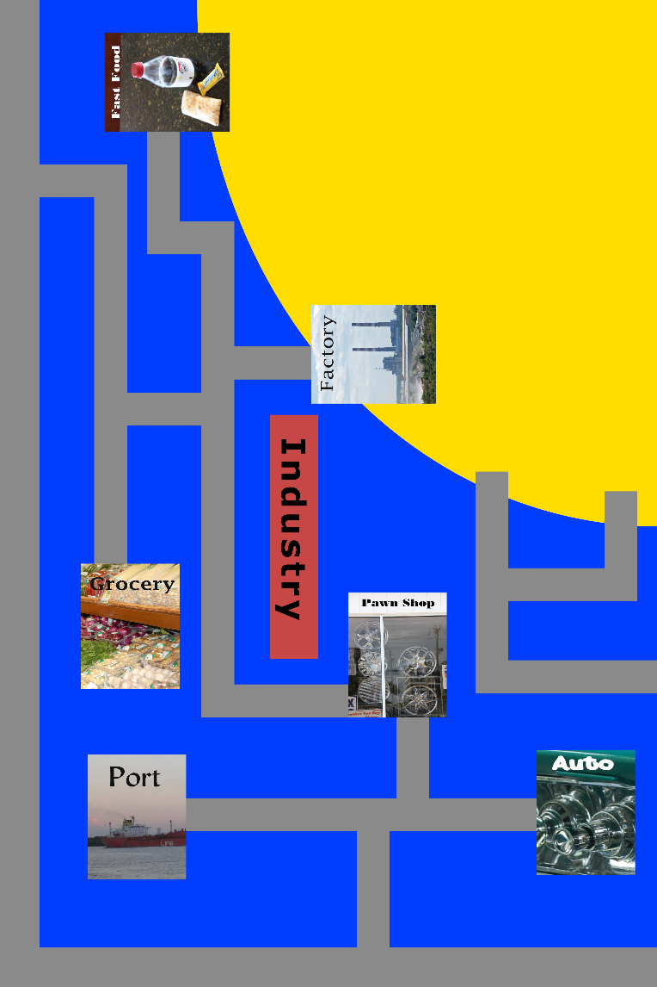
- Little factories
- Auto stuff around auto shop
- Little parking lot by fast food?
- Mining area?
- Gravel Road

Country Section
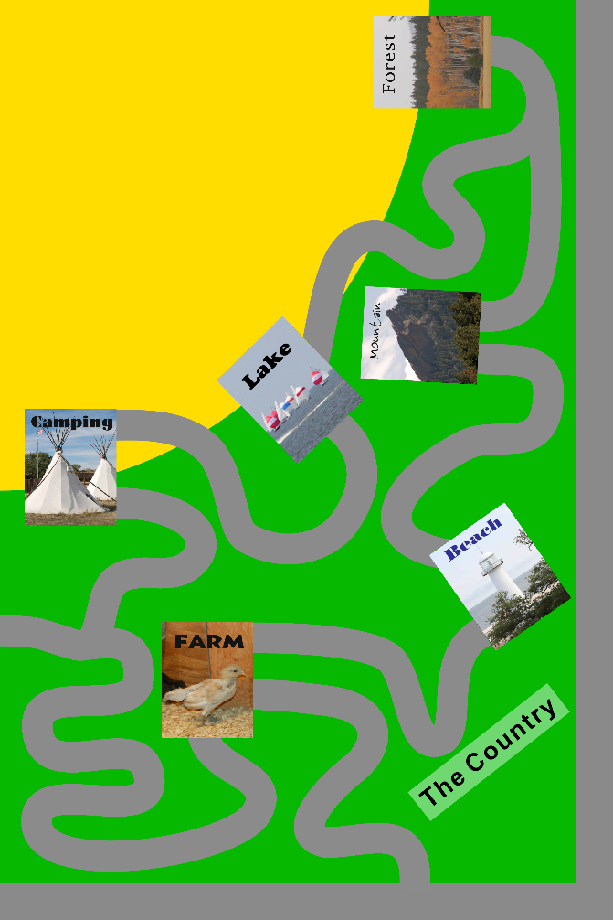
- Dirt road paths
- Fields
- Lake
- Beach

